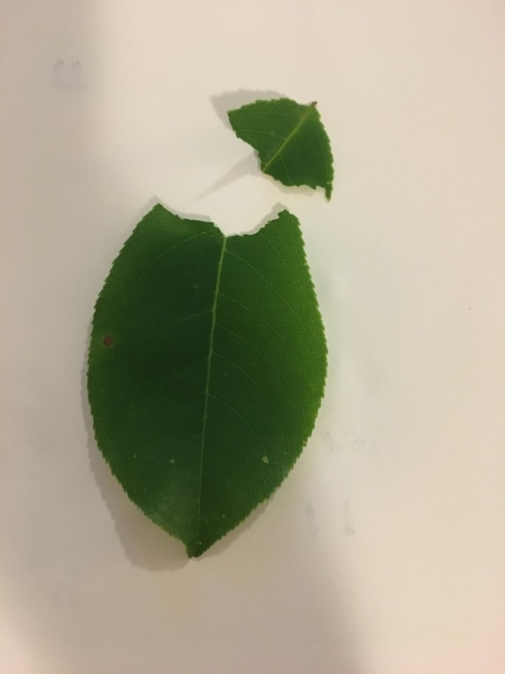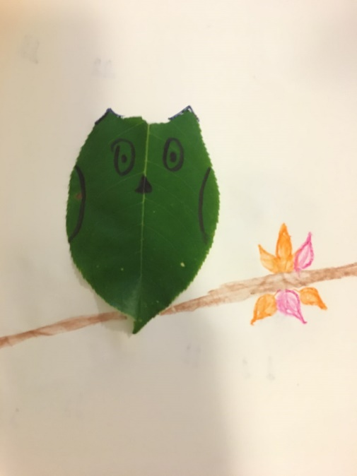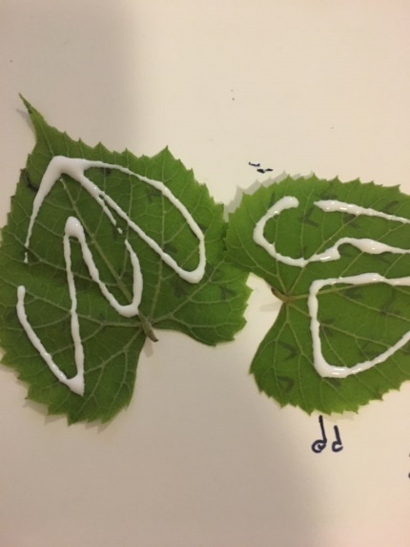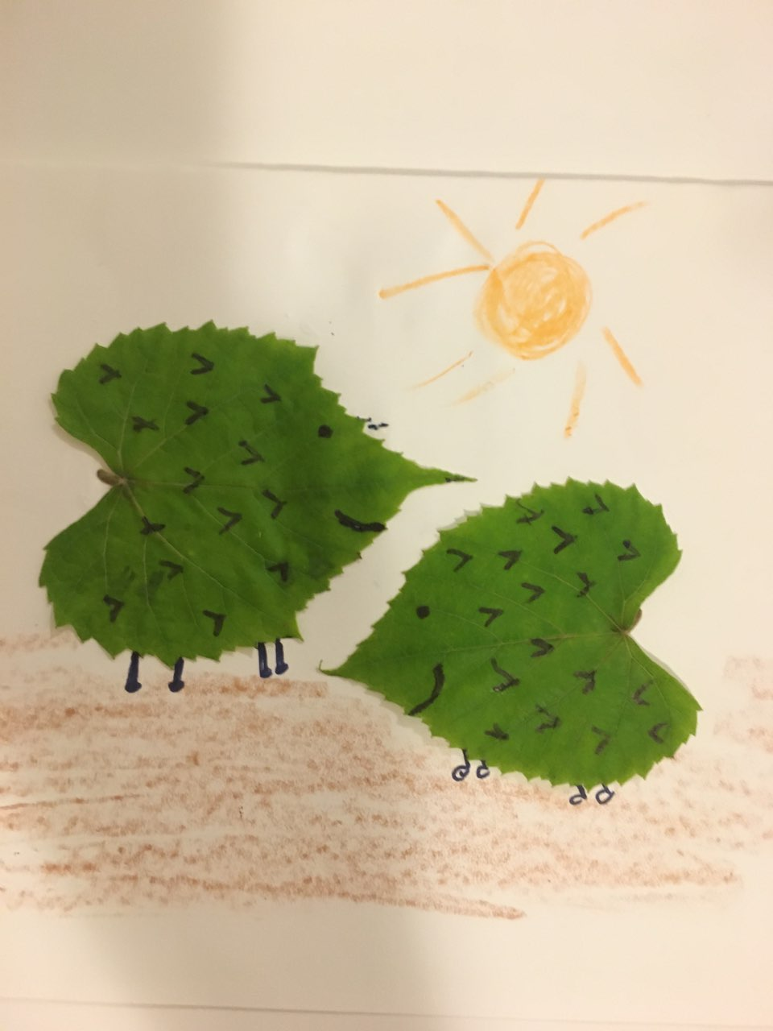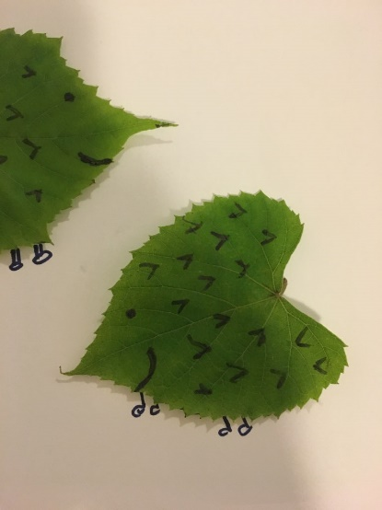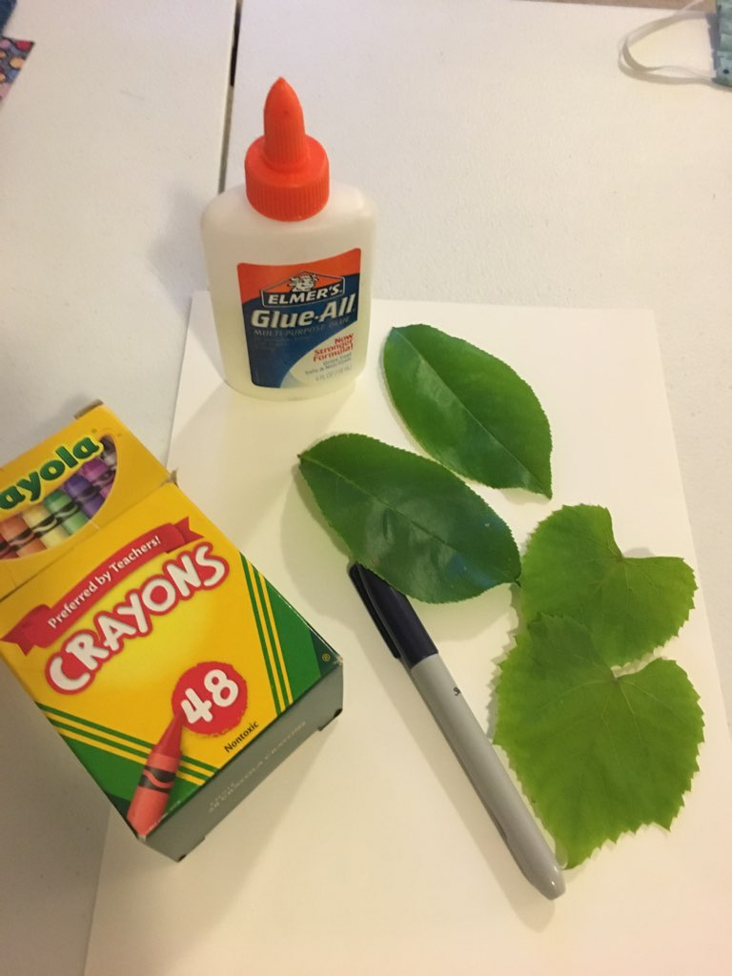

1. Glue leaves on paper.

2. Draw eyes, etc. on leaves and add legs . . . (for owl, tear off V at top of leaf)

3. Color to finish the picture.

Supplies: Crayons, paper, glue, leaves, marker.

Leaf Critters